Tableau Day 4 - Exercises

# Exercise 1

1. Import the ‘employee.csv’, ‘department.csv’ and ‘project.csv’ into Tableau. An auto join will be performed for all 3 tables. If this does not happen, go back to the data source tab and change to inner join. Ensure that it is an inner join.

Answer:

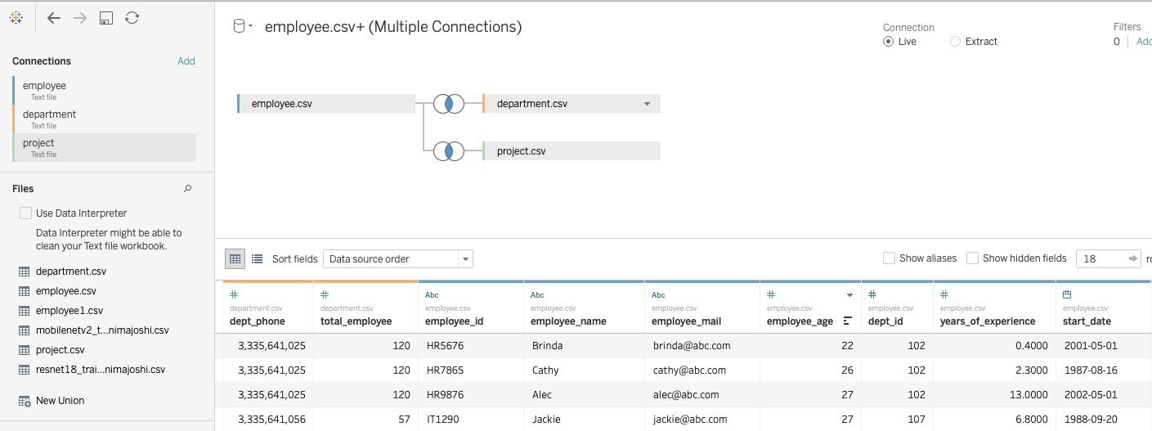

1. In a new sheet, create a treemap of the average age of employees and their department name (Hint: make sure dept_name in Columns and AVG(employee_age) are in your Rows). In addition, create a Level of Detail (LOD) field called “**LOD_field**” that includes dept_name and average total_hours_of_work. What can you infer from the plot?

Answer:

{INCLUDE ([dept_name]):AVG([total_hours_of_work])}

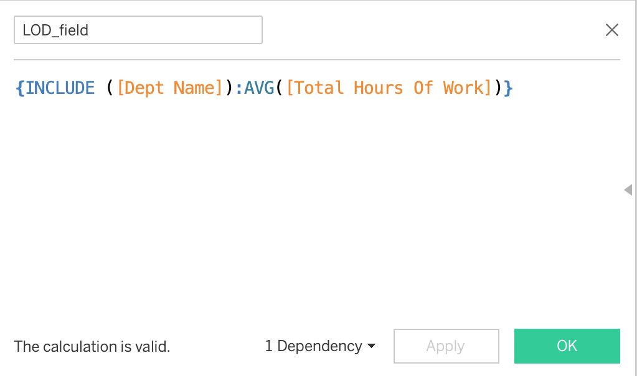

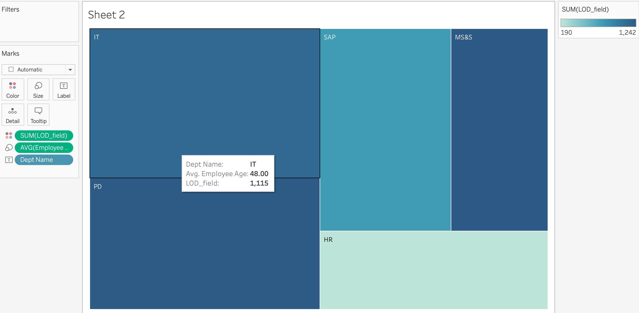

You can infer that the average age of employees in the IT department is the highest, followed by the PD department. Finally, the HR department is the youngest.

# Exercise 2

1. Create a table of dept_id, employee_name and years_of_experience.

Answer:

1. Print the first three letters from the name of the employee.

Answer:

Use formula ‘MID([employee_name],1,3)’

1. Imagine that there has been a mistake during the entry of employee names. Use the formula to replace all mentions of kathy to Cathy.

Answer:

REPLACE([employee_name],"kathy","Cathy")

1. Create a bar chart of the start_date (in Years) in the Rows and AVG(years_of_experience) in the Columns. In addition, use the DATEPART formula to display the month of the start_date.

Answer:

1. Convert the dept_id to STR type.

Answer:

1. Create a new calculated field called “Above30 / Below30” using the average age of the employees. If the average age is greater than 30, designate the department as Above30. Otherwise, it is Below30.

Answer:

